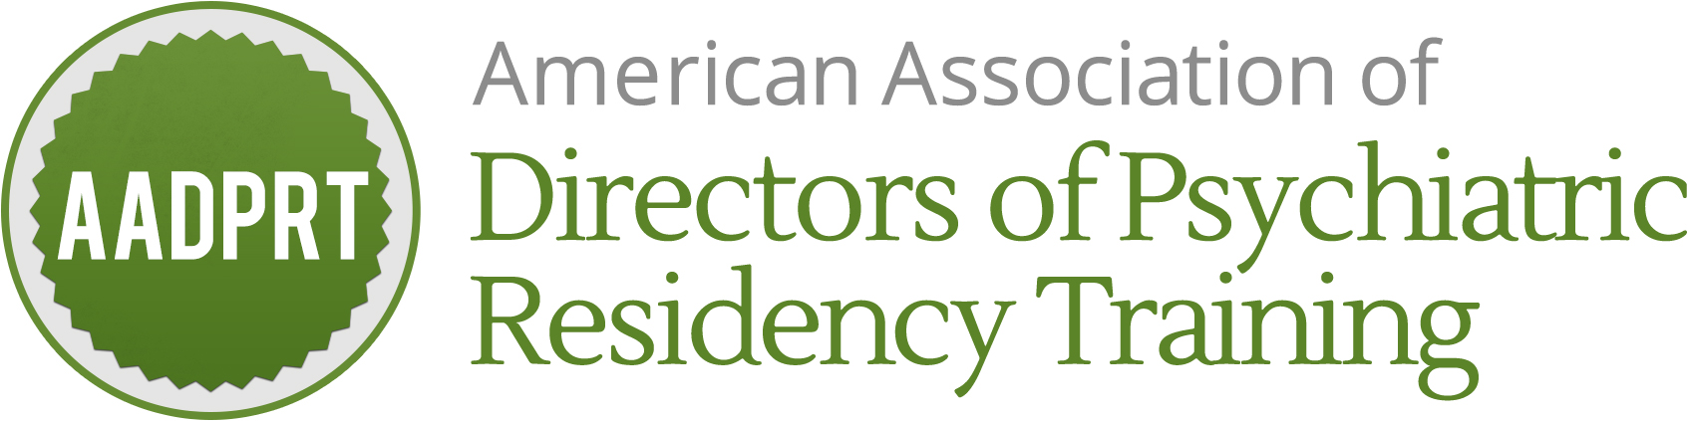

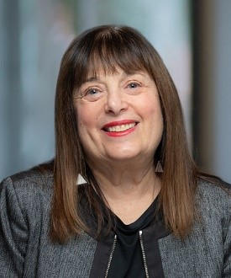
Biosketch
Carol Bernstein, MD
AADPRT Position: Liaison, AACDP

Carol A. Bernstein is Professor and Vice Chair for Faculty Development and Wellbeing, Departments of Psychiatry and Behavioral Science and Obstetrics and Gynecology and Women’s Health at the Montefiore Medical Center /Albert Einstein College of Medicine. She is also a Senior Scholar for the Accreditation Council for Graduate Medical Education (ACGME). She was previously Vice Chair for Education, Director of Residency Training in Psychiatry, Associate Dean for Graduate Medical Education and Designated Institutional Official at NYU as well as Past-President of the American Psychiatric Association. She is the recipient of numerous awards including the APA NIMH Vestermark Psychiatric Educator Award and the ACGME John Gienapp Award for notable contributions to Graduate Medical Education.

Dr. Bernstein completed medical school at the Columbia University College of Physicians and Surgeons. Following an internship in internal medicine at St. Luke's/Roosevelt Medical Center in New York, she completed her psychiatric residency training at Columbia University/ New York State Psychiatric Institute. From 2010-2016, Dr. Bernstein served on the Board of Directors of the ACGME. She is also a member of the Action Collaborative on Clinician Wellbeing and Resilience of the National Academy of Medicine.

